CSA1505-Cloud computing and big data analytics
3-Student Attendence
The Student Attendance Management System in Zoho Creator provides a simple and efficient way to record, manage, and monitor student attendance. It allows faculty to enter attendance details through easy-to-use forms, store records securely in the cloud, and generate reports instantly. The system reduces manual paperwork, improves accuracy, and enables quick searching, filtering, and updating of attendance records. With cloud-based access, authorized users can view attendance data anytime and from any device, making attendance management faster, more reliable, and organized.
INPUT
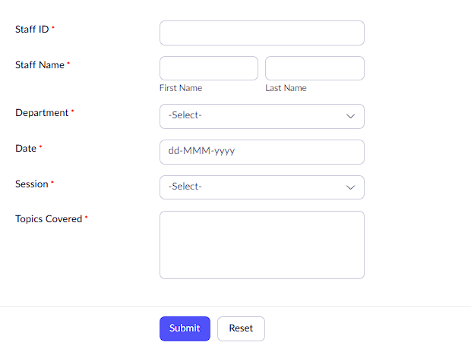

OUTPUT:

